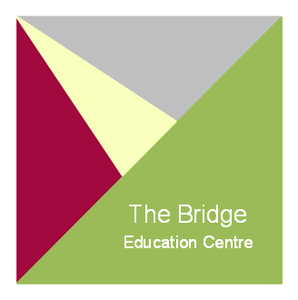
Active Curriculum Instructor – Adventures Outdoors/Vocational Learning/ Work Experience & Sporting Activities

Closing date: 09th May 2024
Interview date: TBC
Salary Type: HCC Grade E - £30,859 - £33,951 depending on experience
Contract: Permanent - Full time

The Active Curriculum Instructor will develop, manage, help to deliver and quality assured an alternative programme for pupils at The Bridge Education Centre.
You will work in collaboration with our Academic and Therapeutic specialist teams to provide support, engage, stretch and challenge young people who present with a spectrum of needs.
All pupils who attend the Bridge Education Centre benefit from our Active curriculum as a part of their daily timetable.

Active Curriculum Core Principals - Resilience, communication, self belief, self management, problem solving and team work.

The curriculum aims to support children to;
Improve emotional resilience
Gain a positive impact upon mental and physical health through daily activity
Enable greater understanding of team working and personal responsibility
Learn new skills and activities not previously experienced
Improve self-discipline, self-esteem and empathy
Develop key social skills
Working in the outdoors; bush craft, camp skills and orienteering alongside climbing, skiing & canoeing
Gain activity specific qualifications such as junior sports leaders, trampolining, coaching etc
Add value to their academic curriculum through a cross team collaborative approach giving pupils direct experience of theory in practice.

The child lies at the heart of our practice and you would be able to demonstrate: unconditional positive regard, academic excellence, the highest expectations for the children and yourself, develop a restorative teaching approach to behaviour and possess the dynamism, imagination and skill to work collaboratively at all levels toward improved outcomes for our children.

If you possess what it takes to make a difference and are deeply motivated to educate, engage and inspire children we want to hear from you.
The Bridge Education Centre has the highest reputation for improving the lives of children in difficult circumstances, an excellent proven record and the expertise to take your practice to the next level.

.

​​

Essential Requirements

D1 driving licenced or have the ability to obtain through training provided
Commitment to high educational, professional and personal standards
Possess a calm manner and resilient nature.

Preferable
Previous experience of leading a team and/or line managing colleagues,
MIDAS trained minibus driver
Previous experience working with children presenting significant SEMH needs.
Evidence of further relevant training

​
​
Application Procedure

An application form can be obtained by email office.bridge@bec.hants.sch.uk, from the school website www.bec-hants.co.uk, or by telephone on 02382 515567

